AI LAB ASSESSMENT 3

Name: K. Manoj Kumar
Register Number:23MIS0159
Course code: ISWE302P

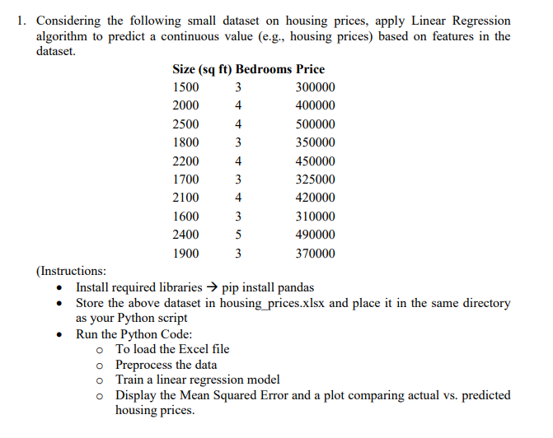
CODE:
import pandas as pd
import matplotlib.pyplot as plt
from sklearn.model_selection import train_test_split
from sklearn.linear_model import LinearRegression
from sklearn.metrics import mean_squared_error

data=pd.read_excel("housing_prices.xlsx")

print(data)

X=data[['Size (sq ft)','Bedrooms']]

y=data['Price']

X_train,X_test,y_train,y_test=train_test_split(X,y,test_size=0.2,random_state=42)

model=LinearRegression()
model.fit(X_train,y_train)

y_pred=model.predict(X_test)
mse=mean_squared_error(y_test,y_pred)
print("Mean sqayre Error ",mse)

print('\n Model co efficient :')
print("Size co efficient :",model.coef_[0])
print("Bedrooms coefficient :",model.coef_[1])
print("Intercept:",model.intercept_)

plt.scatter(y_test,y_pred)
plt.xlabel=("Actual price")
plt.ylabel=("Predicted price")
plt.title("Actual vs Predicted Housing prices")

plt.show()

OUTPUT:
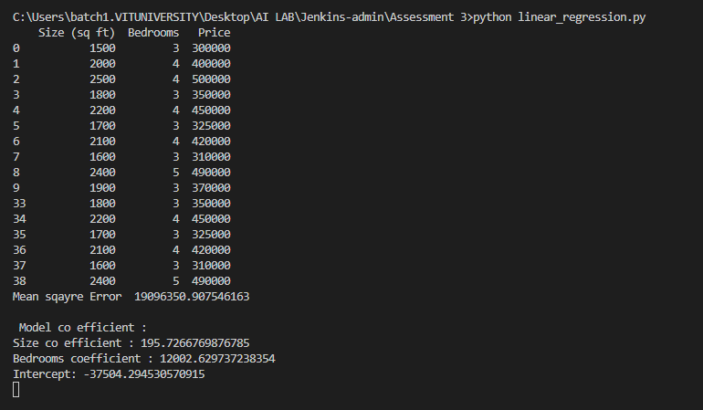
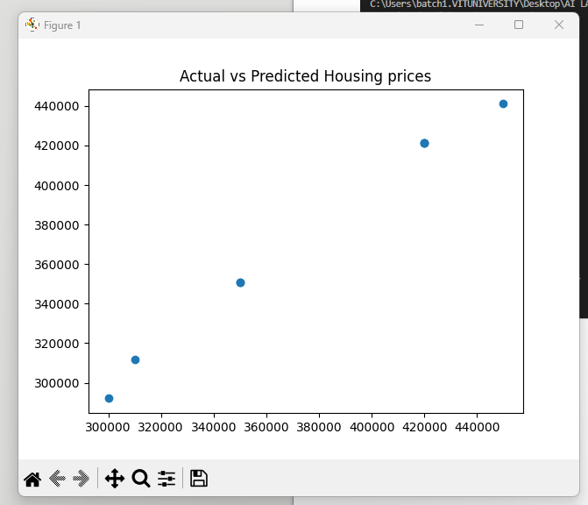
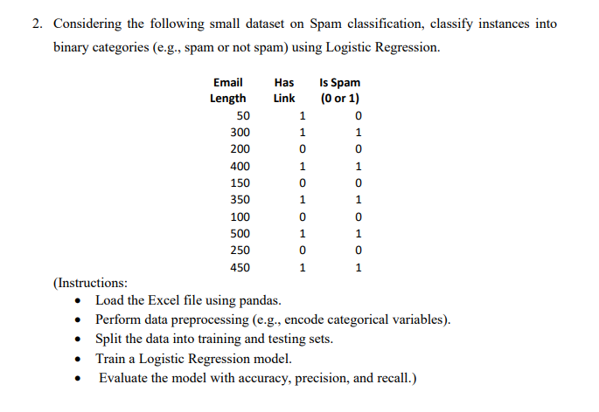
CODE:
import pandas as pd
import matplotlib.pyplot as plt
from sklearn.model_selection import train_test_split
from sklearn.linear_model import LogisticRegression
from sklearn.metrics import accuracy_score,precision_score,recall_score,classification_report

data=pd.read_excel("spam_data.xlsx")

print(data)

X=data[['Email Length','Has Link']]

y=data['is Spam']

X_train,X_test,y_train,y_test=train_test_split(X,y,test_size=0.2,random_state=42)

model=LogisticRegression()
model.fit(X_train,y_train)

y_pred=model.predict(X_test)

acc=accuracy_score(y_test,y_pred)
prec=precision_score(y_test,y_pred)
rec=recall_score(y_test,y_pred)

print(acc)

print(prec)

print(rec)

print(classification_report(y_test,y_pred))
plt.scatter(y_test,y_pred)
plt.xlabel=("Actual pred")
plt.ylabel=("Predicted prd")
plt.title("Actual vs Predicted values")
plt.show()

OUTPUT:
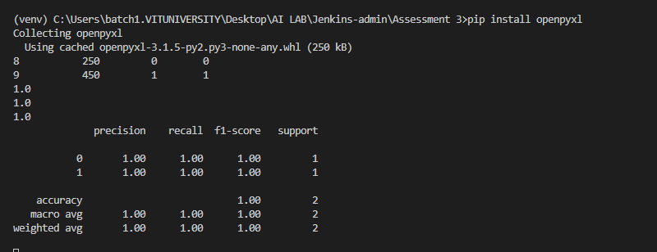
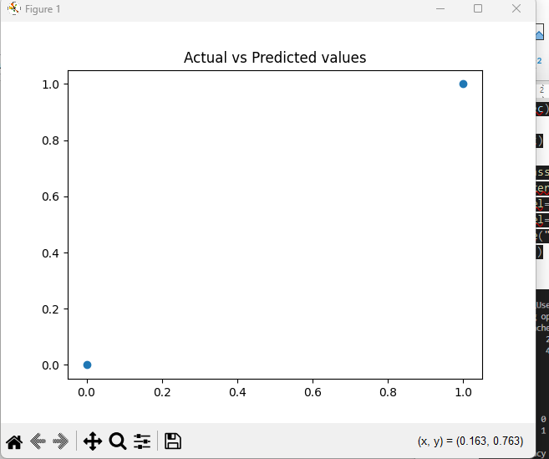

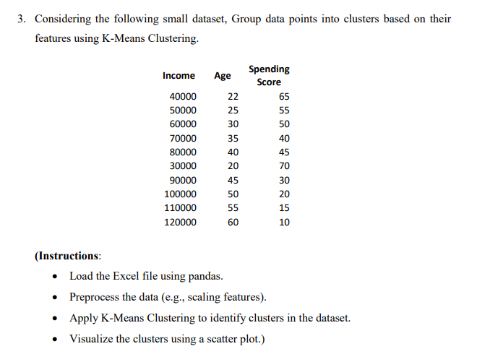
CODE:
import pandas as pd
from sklearn.preprocessing import StandardScaler
from sklearn.cluster import KMeans
import matplotlib.pyplot as plt

df=pd.read_excel("Spending_score.xlsx")

print(df.head())

X=df.select_dtypes(include=['float64','int64'])

scaler=StandardScaler()
X_Scaled=scaler.fit_transform(X)

k=3
kmeans=KMeans(n_clusters=k,random_state=42)

cluster=kmeans.fit_predict(X_Scaled)

df['Clusters']=cluster

print(df)

plt.scatter(X_Scaled[:,0],
X_Scaled[:,1],c=cluster)
plt.xlabel("Income")
plt.ylabel("Age")
plt.title("K-Means clustering")
plt.show()

OUTPUT:
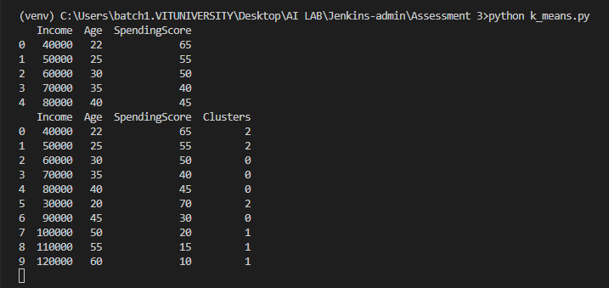
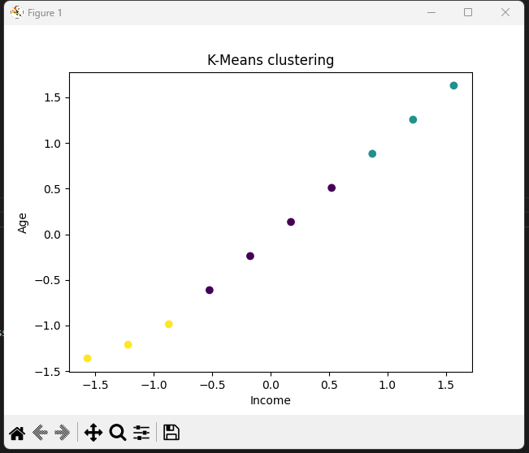

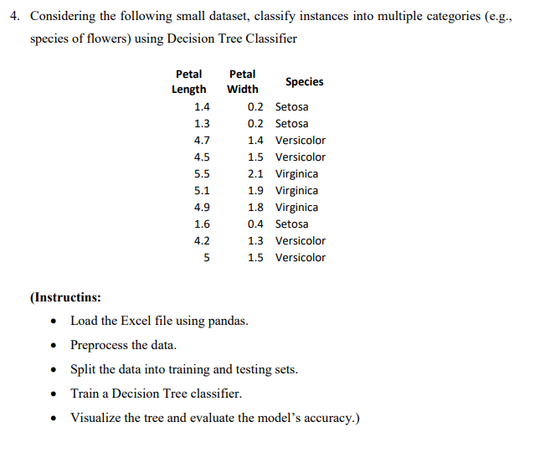
CODE:
import pandas as pd
from sklearn.model_selection import train_test_split
from sklearn.tree import DecisionTreeClassifier,plot_tree
from sklearn.preprocessing import LabelEncoder
from sklearn.metrics import accuracy_score
import matplotlib.pyplot as plt

df=pd.read_excel('Petal_dataset.xlsx')

X=df[['PetalLength','Petalwidth']]
y=df['Species']

encoder=LabelEncoder()
y_encoded = encoder.fit_transform(y)

X_train,X_test,y_train,y_test = train_test_split(X,y_encoded,test_size=0.3,random_state=42)

model=DecisionTreeClassifier()
model.fit(X_train,y_train)

y_pred=model.predict(X_test)

accuracy_score=accuracy_score(y_test,y_pred)
print('Accuracy :',accuracy_score)

plt.figure(figsize=(12,0))
plot_tree(model,
feature_names=['PetalLength','PetalWidth'],
class_names=encoder.classes_,
filled=True)

plt.show()

OUTPUT:
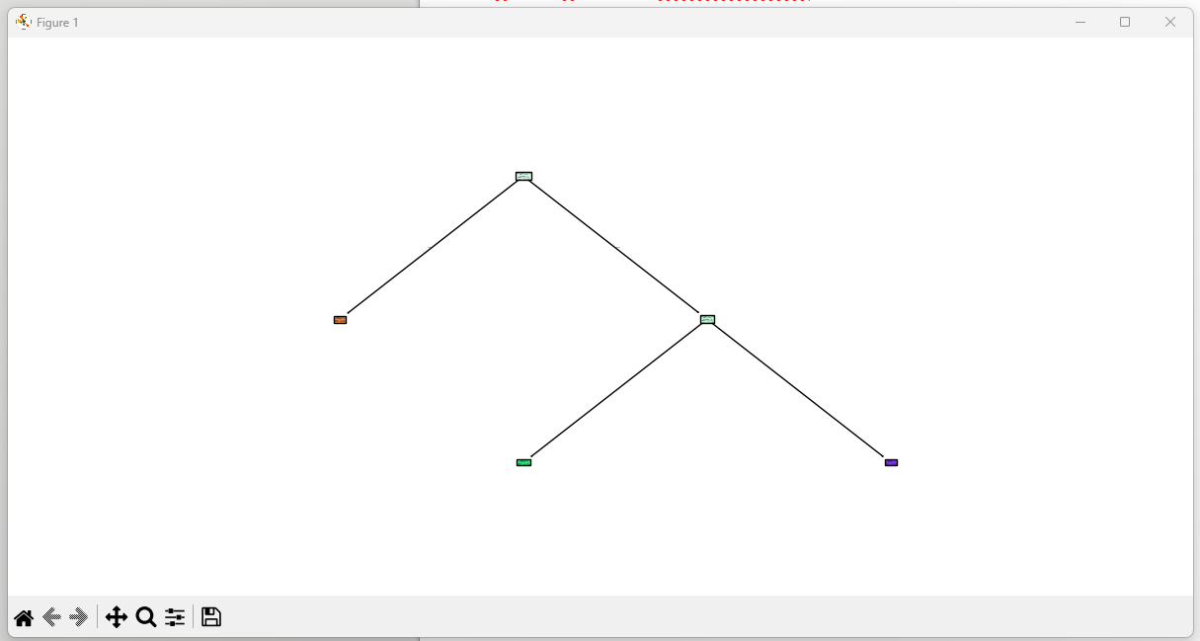

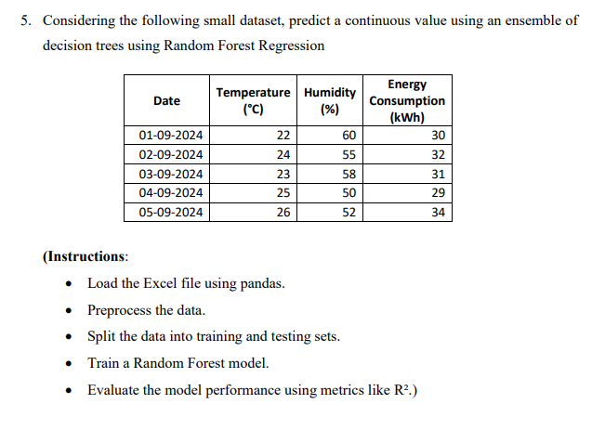
CODE:
import pandas as pd
from sklearn.model_selection import train_test_split
from sklearn.ensemble import RandomForestRegressor
from sklearn.metrics import r2_score

df=pd.read_excel('EnergyConsumption_data.xlsx')
df['Date']=pd.to_datetime(df['Date'])

df['Date']=df['Date'].map(pd.Timestamp.toordinal)

X=df[['Date','Temperature','Humidity']]
y=df['EnergyConsumption']

X_train,X_test,y_train,y_test=train_test_split(X,y,test_size=0.3,random_state=42)

model = RandomForestRegressor(n_estimators=100,
random_state=42)
model.fit(X_train,y_train)

y_pred=model.predict(X_test)

r2=r2_score(y_test,y_pred)
print('R2 score :',r2)

print("Actual :",list(y_test))

print("Predicted :",list(y_pred))

OUTPUT:

